#### **PHYSICS 12 – Electricity and Magnetism Topic Test 1 2019**

#### **Question/Answer Booklet**

**NAME: ____________________________________**

**TIME ALLOWED FOR THIS PAPER**

Working time for paper: 45 minutes

**STRUCTURE OF THE PAPER**

|  |  |  |  |  |
| --- | --- | --- | --- | --- |
| Section | No. of questions | No. of questions to be attempted | No. of marks out of 40 |  |
| A: Short Answers | 6 | ALL | 11 |  |
| B: Problem Solving | 4 | ALL | 29 |  |
|  |  |  |  |  |

**Section A: Short Answer**

Marks Allocated: 11 marks out of 40 total marks.

This section has 6 questions. Answer the questions in the spaces provided.

________________________________________________________________________

**Question 1 [1 mark]**

Two current carrying conductors were placed close together as shown below. What is the effect of the two fields on each other? Circle the correct response

 

Attraction Repulsion No effect

**Question 2 [4 marks]**

In the diagram opposite, RS is free to move. How will RS move if the switch is closed? Circle the correct response.

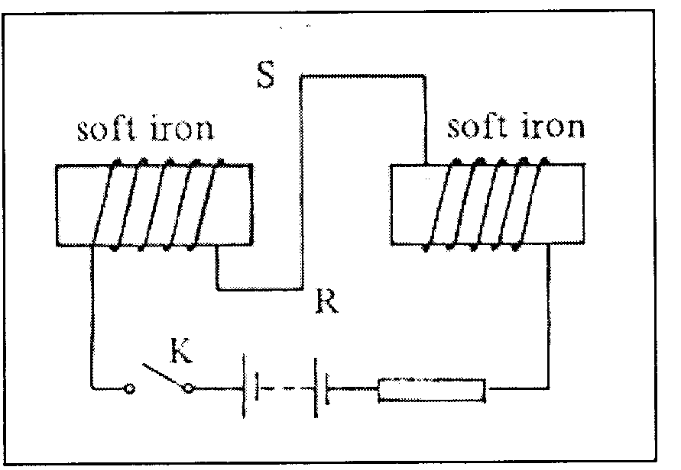

A rotate

B into the paper

C out of the paper

D downward

E upward

Explain your choice. Annotate the diagram if this will help to explain your choice.

**Question 3 [3 marks]**

Two point electric charges are separated by a certain distance and experience a repulsive force of magnitude F. If the distance between them is reduced to one third of its previous value, and one of the charges is now doubled, calculate the magnitude of the new force, in terms of F.

**Question 4 [1 mark]**

Which line, **A** to **D**, in the table correctly describes the trajectory of charged particles which enter separately, at right angles, a uniform electric field, and a uniform magnetic field?

|  |  |  |
| --- | --- | --- |
|  | **uniform electric field** | **uniform magnetic field** |
| **A** | parabolic | circular |
| **B** | circular | parabolic |
| **C** | circular | circular |
| **D** | parabolic | parabolic |

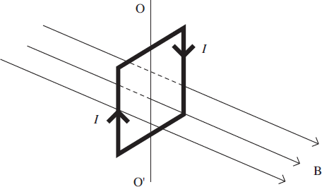**Question 5 [1 mark]**

The diagram shows a vertical square coil whose plane is at right angles to a horizontal uniform magnetic field B. A current, I, is passed through the coil, which is free to rotate about a vertical axis OO'.

Which one of the following statements is correct?

**A**      The forces on the two vertical sides of the coil are equal and opposite.

**B**      A couple acts on the coil.

**C**      No forces act on the horizontal sides of the coil.

**D**      If the coil is turned through a small angle about OO' and released, it will remain in position.

**Question 6 [1 mark]**

Which one of the following statements is correct?

The force between two charged particles

**A**        is always attractive

**B**        can be measured in C2 F–1 m–1

**C**        is directly proportional to the distance between them

**D**        is independent of the magnitude of the charges

**Section B: Problem Solving**

Marks Allocated: 29 marks out of 40 total marks

This section has 4 questions. A nswer the questions in the spaces provided.

________________________________________________________________________

**Question 7 [10marks]**

(a)     The equation *F* = *Bqv* may be used to calculate magnetic forces on moving charges.

(i)      State the condition under which this equation applies. (1 mark)

(b)     The figure belowshows the path followed by a stream of identical positively charged ions, of the same kinetic energy, as they pass through the region between two charged plates. Initially the ions are travelling horizontally and they are then deflected downwards by the electric field between the plates.

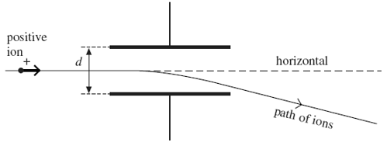

While the electric field is still applied, the path of the ions may be restored to the horizontal, so that they have no overall deflection, by applying a magnetic field over the same region as the electric field. The magnetic field must be of suitable strength and has to be applied in a particular direction.

(i)      State the direction in which the magnetic field should be applied. (1mark)

(ii)     Explain why the ions have no overall deflection when a magnetic field of the required strength has been applied. (2 marks)

(iii)     A stream of ions passes between the plates at a velocity of 1.7 x 105ms–1. The separation *d* of the plates is 65 mm and the potential difference across them is 48 V. Calculate the value of magnetic field strength *B* required so that there is no overall deflection of the ions, stating an appropriate unit. (4 marks)

Answer = ______________________

(c)     Explain what would happen to ions with a velocity higher than 1.7 x 105ms–1 when they pass between the plates at a time when the conditions in part (b)(iii) have been established. (2 marks)

**Question 8 [6marks]**

The rectangular coil shown below is to be used in a small electric motor in a toy. The coil has 100 turns of wire and each turn is rectangular with sided 0.04 m and 0.02 m as shown. The magnetic flux density is constant through the coil at 0.06 T.

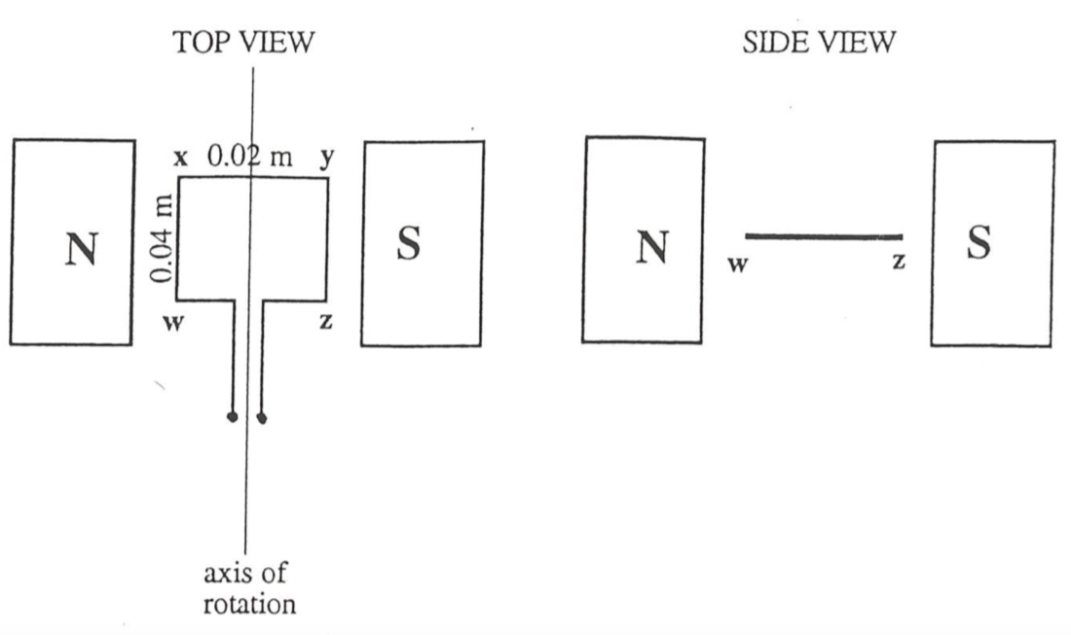

The force on the side WX of the coil is 0.05 N in an upward direction perpendicular to WX. (that is, out of the page towards you in the TOP VIEW of the coil)

1. Indicate, on the diagram, the direction of the current in the side WX and the side ZY. (1 mark)
2. Calculate the magnitude of the current in the coil. (2marks)
3. Calculate the value of the maximum torque on the coil. (2 marks)
4. There are two positions of the coil during its motion at which the toque on the coil is zero. On the **SIDE VIEW diagram**, draw of one of these positions. (1 mark)

**Question 9 [7 marks]**

Two 2.00m conductor rods are placed one above the other as shown.

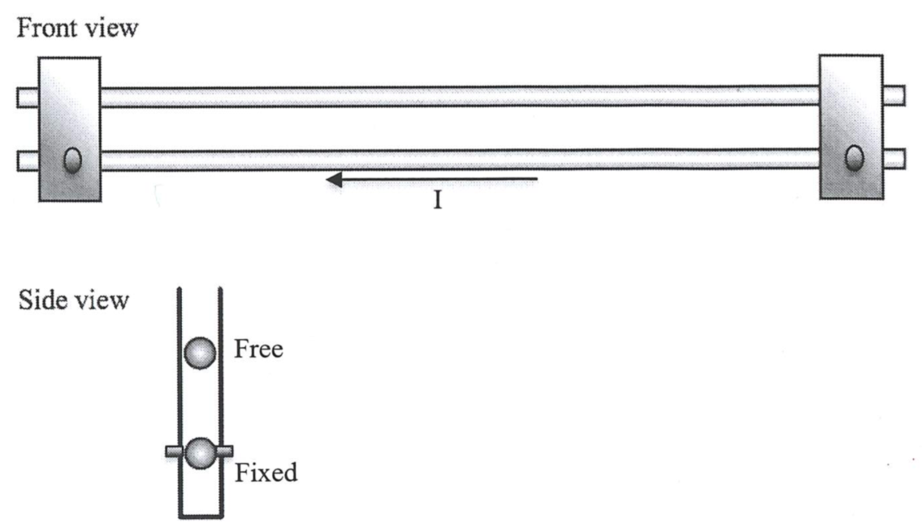

The bottom conductor is held in place by brackets and the top one is free to move up and down. Each conductor has a mass of 0.0100kg and a current of 20.0A moves through the bottom conductor from right to left as shown in the front view above.

1. On the front view diagram, sketch the direction of current that must flow in order for the top rod to levitate (remain in static equilibrium). (1 mark)
2. Calculate the strength of the magnetic field (produced by the bottom rod) a distance of 4.00mm above the bottom rod. (3marks)
3. Calculate the current flowing in the top rod that is necessary to suspend it 4.00mm above the bottom rod. (3 marks)

**Question 10 [6 marks]**

A beam of electrons having energies between 10 and 100 keV passes through a slit into an evacuated chamber as shown. A magnetic field makes the electrons move in a semicircle and those with a particular velocity hit the wall at point P.

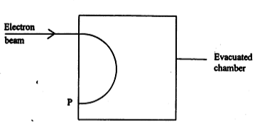

1. Indicate on the diagram the direction of the magnetic field that would result in the electron following this path. (1 mark)
2. Explain why the charged particles move in a circular motion in the direction of P. (2 mark)
3. Sketch (on the diagram) the path taken by an electron with a higher velocity. (1 mark)
4. Sketch (on the diagram) the path of a proton when fired with the same velocity into the same evacuated chamber. (2 marks)